

**American International University- Bangladesh**

**CSC 2209: Object Oriented Programming 1 (JAVA)**

**CO1 Evaluation**

**Project Summary Report**

**Summer 18-19**

**Project Title: DHAKA CORRECTIONAL CENTRE**

**Section: L**

|  |  |
| --- | --- |
| Student Name | Student Id |
| Md.Sajedul Islam | **18-37361-1** |
| Raihan Ahmed | **18-37366-1** |
| Sabbir Ahmmed Osmani | **18-37313-1** |
| Mahbub Hossain Faisal | **18-37337-1** |

**Introduction:**

*This project is about Jail management system.In our country many jails are not well observed especially in Dhaka city.So we tried to make a desktop application that can help an admin to run a jail management system properly.This app will help the admin to find all the information of the prisoners,guards,doctors and other stuffs within a short period of time and he will be able to keep an eye on everything and also will be able to take necessary actions.Then doctors also can use the application to take care of the health conditions of the prisoners.*

**User Category:**

There are two types of Users here. They are:

* Admin
* Doctor

**Feature List:**

In this project the “Admin” has the following features:

* Can add/delete prisoners and also can see the information of the prisoners
* Can add/delete guards and also can see the information of the guards
* Can add/delete doctors and also can see the information of the doctors
* Can add/delete other stuffs and also can see the information of the other stuffs

In this project the “Doctor” has the following features:

* Check health status from prisoner list
* Can check his or other doctors information

**GUI Description:**

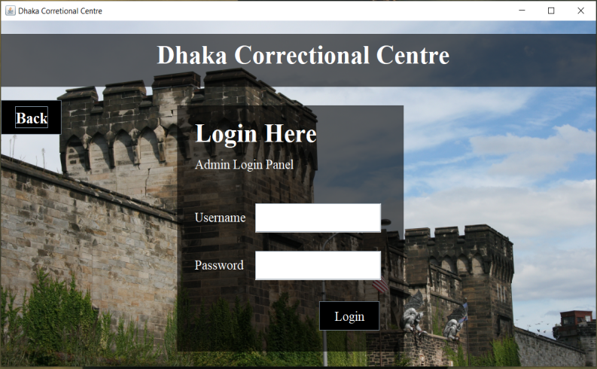

That is our Admin login frame.Admin can give the username & password and if they are correct the admin can access the “Admin portal”.If the username/password is wrong they can’t log in to the portal.Error message dialog will be shown.

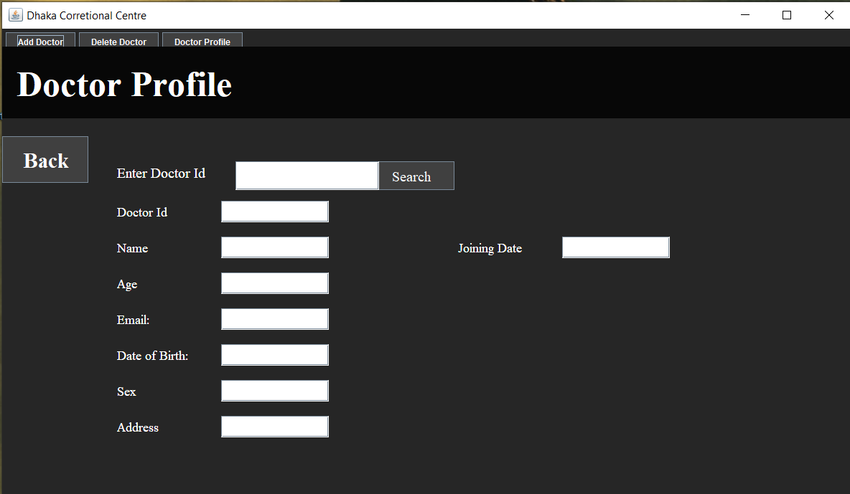

This is a frame where the information of a doctor can be seen.Both admin and doctor can login and see it.Admin can see the information of every doctor.Also if any doctor wants he can see his profile or any other doctor’s profile.Just the admin/doctor has to enter the id and all the information will be generated.

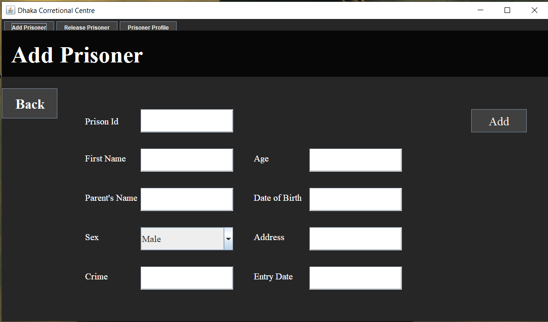

This frame is for to add prisoners in the database.Admin will enter the necessary information like prisoner id,name,parent’s name,sex,crime,entry date,date of birth,age etc will click the “Add” button.If he do so the prisoner’s information will be added to the database.

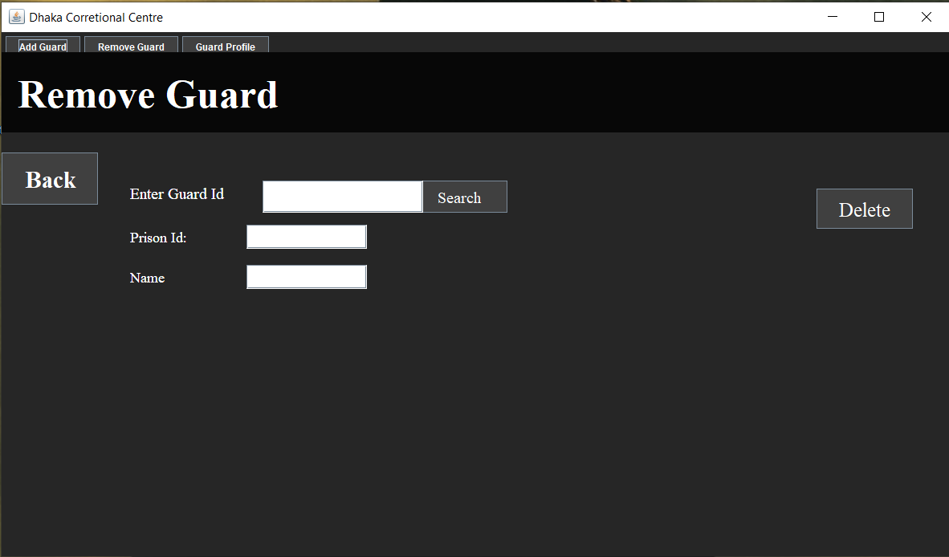

This frame is for to remove guards information from the database.If admin fire any guards or in case any guard’s work opportunity has gone then his information will not be necessary anymore.So admin has to just enter his id and prison id and click “Delete”.His information will be deleted.

**Database Table Description:**

Admin Table:

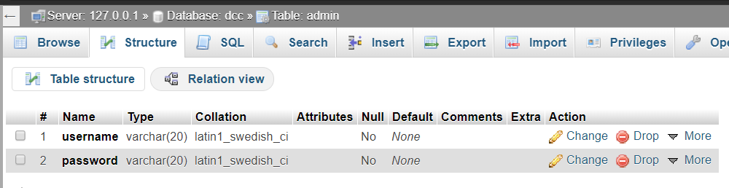

Doctor Table:

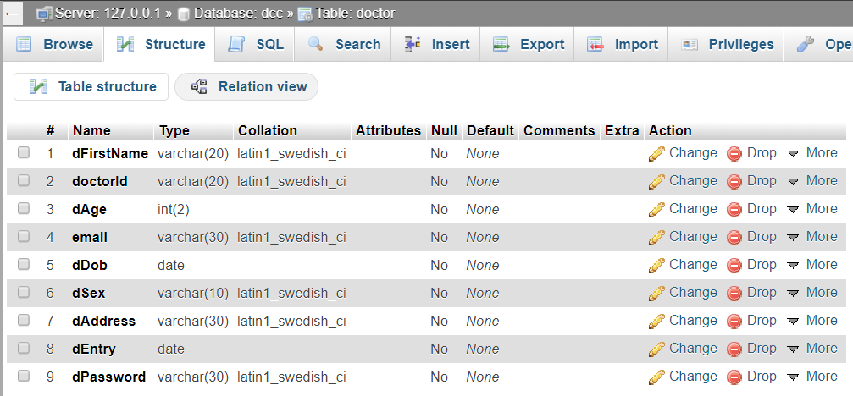

Guard Table:

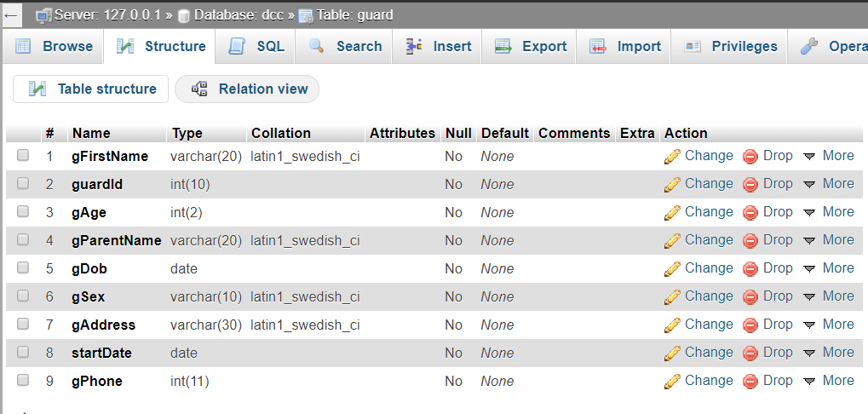

Prisoner Table:

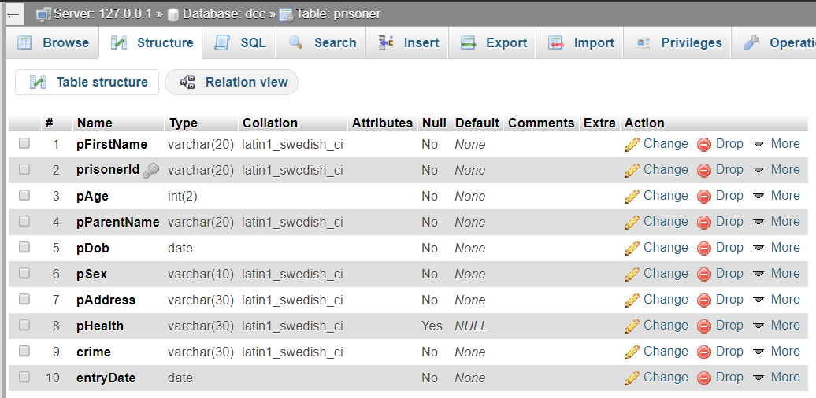

Stuff Table:

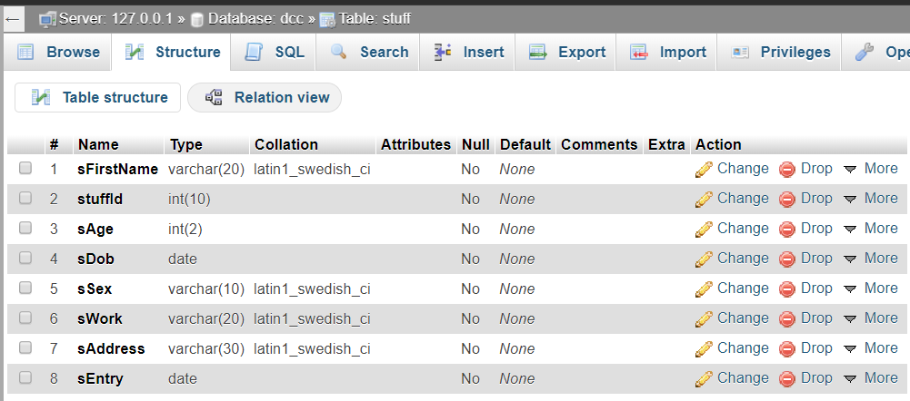

**Class Diagram:**

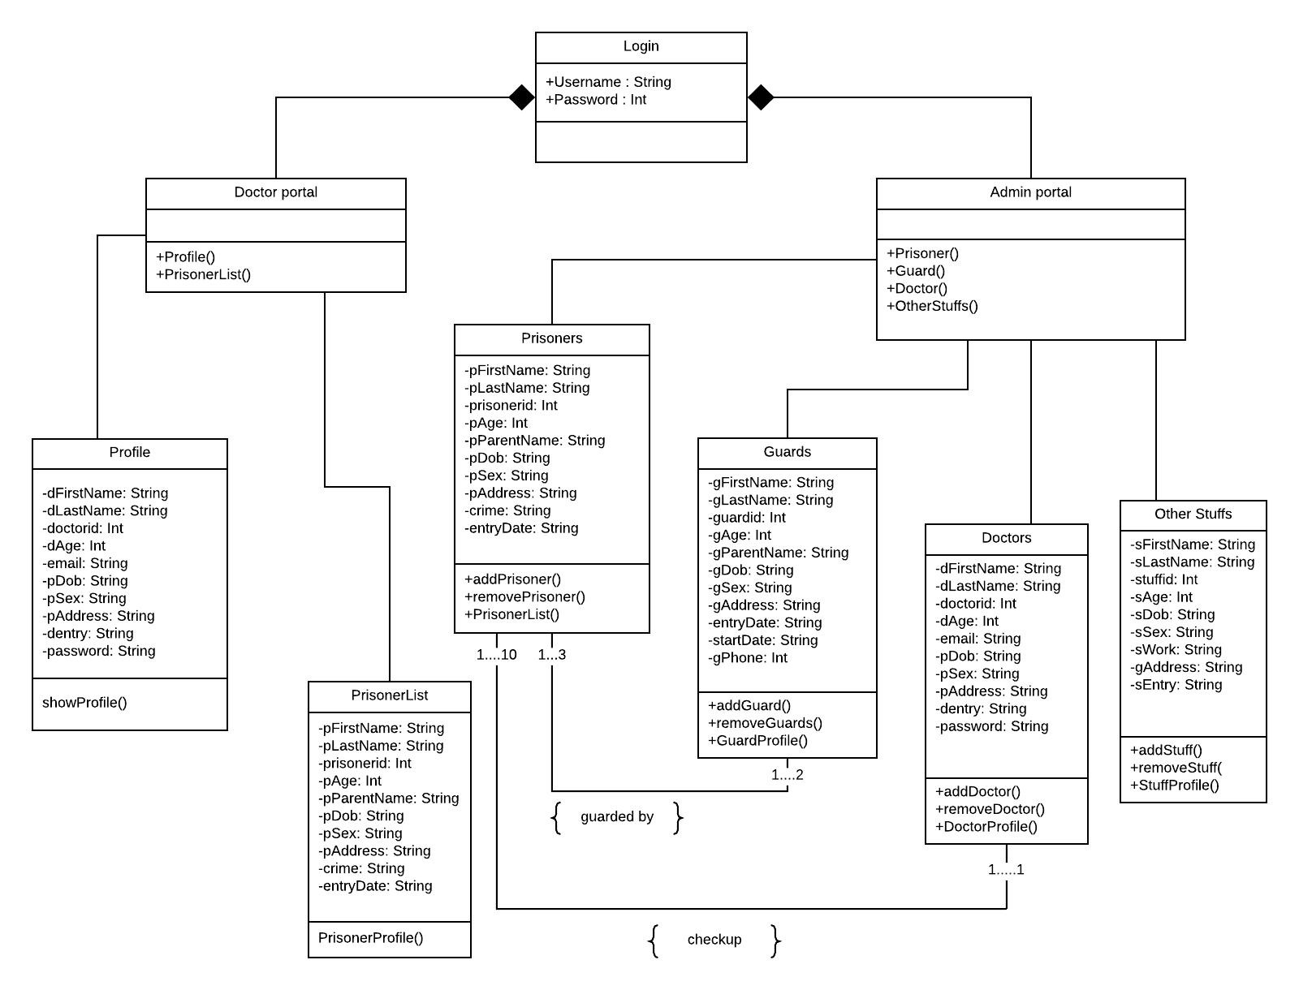

**Tools Used:**

To develop this project we have used the following:

* Sublime text editor 3
* Command prompt

**OOP and Java Concepts Used:**

* Concept 1: Inheritance: All the classes extends JFrame.So inheritance happend.
* Concept 2: Abstraction:All the visual frames are example of abstraction because the backend code will not be seen here.
* Concept 3: Encapsulation: In every class attributes are taken as private. So encapsulation also have been done.

**Impact of this Project:**

This project will help an admin to run a jail management more effectively.As he can see all the information in front of him,so it will make him more concern about what to do next.As the admin himself can know about all the information,so he doesn’t need to hire any people for this.Then a doctor can also access the portal and after the checkup of the prisoners he can update the health issues.This will also help the admin to know about the prisoner’s health conditions.So,this software will help to maintain the jail management properly and also it is free of cost as the admin will not need any people to maintain the jail management anymore.He can just use this software to do it.

**Limitations and Possible Future Improvements:**

This project definitely has some limitations.For example,The total information of the prisoners,guards,doctors and stuffs can be shown which this software can’t show till now.Then image can be added of the prisoners,guards,doctors and stuffs.More individual stuffs can be added to the application.Moreover the overall structure of the application can be improved.Food management (like supply of food,daily meal routine etc) can be added also.So these are the possible improvements that can be made in future.